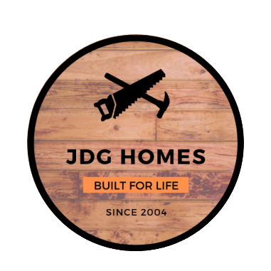

JDG Homes Standard Features
Valley at Great Hills

General/Energy Saving
Exterior
- Outdoor Kitchenette*
- Sod & Irrigation with Rain Sensor
- Landscaping/Flower Beds
- 6ft Wooden Privacy Fence with Metal Posts
- Covered Porches and Patios
- Front Rock and/or Stucco Exterior

- Spray Foam Insulation
- Soundproof Master Suite, Laundry & Bathrooms
- Double Pane Low E Vinyl Tilt Sash Windows
- 3500 PSI Concrete
- 30 Year Composition Roof
- Oversized Water Supply Line
- 15 Seer Main AC Unit
- 2 Car Garage with Heated/Cooled Mini Split
- LED Disk Lighting and Bulbs

Interior Features
General
- Wood Look Vinyl Flooring & Tile Bathrooms
- Custom Built Cabinets
- Soft Close Cabinet Doors & Full Extension Drawers
- Ceiling Fan in Living Room, All Bedrooms & Patio
- Electric Fireplace in Living Room
- 3cm Granite or Quartz Counters Throughout
Kitchen
- Pull-out Hidden Trash Cabinet
- Under Cabinet/Counter Lighting
- Stainless Steel GE Appliances
- Ceramic Tile Backsplash
- Walk In Pantry*
- LED Disk Lighting and Pendant Lights
- Oversized Undermount Sink
Bath
- Stand Alone Tub in Master Bath*
*Plan Permitting/On Most Houses
- Master Bath Walk In Shower

